**Eclipse during Pregnancy**

Eclipse during pregnancy is said to leave an effect on pregnant woman. There are some common do’s and don’ts during eclipse which a pregnant woman must follow. But what is an eclipse and how does a mere moon’s reflection affect a baby in a mother’s womb? Let’s find out!

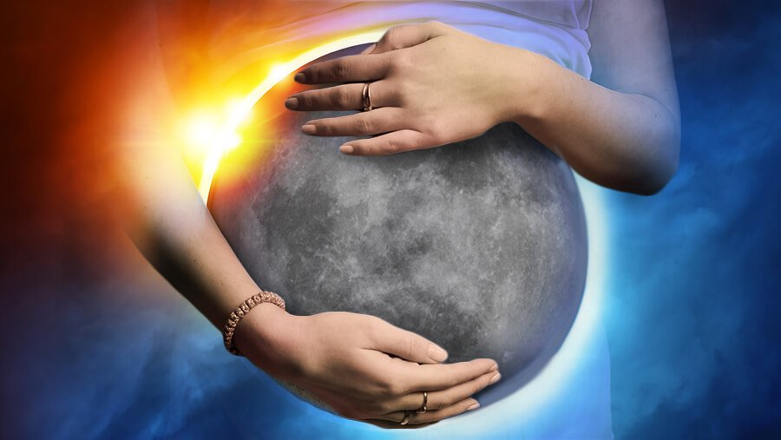

**A myth or a truth?**

A lunar eclipse occurs during full moon night. The moon appears bloody red in color. It occurs when the Sun, the Earth and the Moon align themselves in a line, Earth sandwiched between Sun and Moon. Earth completely blocks Sun’s light to directly reflect through moon. The bloody red color is due to refraction of Sun’s light through the surface of Earth.

Lunar eclipse and pregnancy superstitions are very famous among Indians. Eclipse during pregnancy is said to be harmful for the expectant mother. It is advised to stay to home and do nothing but rest the whole day. Else, an eclipse during pregnancy may cause deformities in the expected baby.

**Lunar eclipse and pregnancy superstitions**

If you believe in a moon’s power and are willing to know how a reflected light can affect a mother and her baby during pregnancy, here are some common do’s and don’ts during eclipse to feed your superstitious thoughts:

* **Don’t make a moon contact**

Watching an eclipse during pregnancy causes several problems. It is advised for the pregnant woman not to look at the moon directly or even using protective shield like sun glasses. Also, avoid going outside during lunar eclipse.

* **Even a few rays can damage!**

Cover the windows and small openings with thick curtains to avoid any contact with light of eclipse during pregnancy. Eclipse rays are said to affect baby’s growth. In addition, these rays of eclipse during pregnancy can produce deformities or birth defects in the baby. Therefore, eclipse and pregnancy precautions must be kept an eye upon.

* **Keep aside sharp objects**

Do not use any sharp metal objects such as knife even for cutting fruits! This may cause birthmarks on the baby’s skin.

* **Work less, rest more**

Avoid any kind of stress or work during lunar eclipse and take as much rest as possible. A lunar eclipse is said to create a powerful ambience in the atmosphere. A little stress can prove to be a major one during eclipse and pregnancy precautions are must to take.

* **Avoid eating or drinking**

An Eclipse lasts only a few minutes. Avoid cooking or eating food during the eclipse. Or even try not to drink water too.

* **A bath washes away all negativities**

Taking a bath is considered a good omen. It signifies that the shadow of eclipse during pregnancy is completely removed from the mother’s body. Also, a lady feels regular body cramps during the pregnancy days. Taking a bath helps in removing cramps. It releases exhaustion from the body and makes it easier to sleep.

These few points add to the list of do’s and don’ts during eclipse.

Some people follow these lunar eclipse and pregnancy superstitions as peace of mind. Others follow these lunar eclipse and pregnancy superstitions to shield themselves from any side effects on the mother and baby. Although there is no harm in following these popular beliefs about lunar eclipse during pregnancy, you must make sure none of your essential works are compromised.

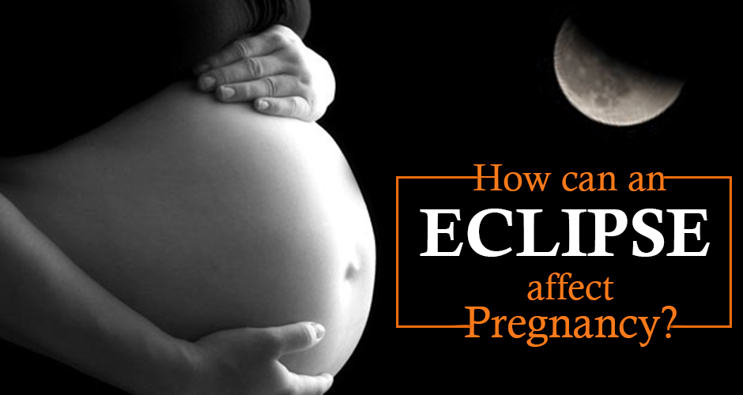

**Eclipse during pregnancy – good or bad?**

Breaking of glass brings good omen to some and bad omen to others, depending on every individual’s opinion. Similarly, scientifically, there is no proof yet found to highlight a negative effect of lunar eclipse during pregnancy.

**Conclusion**

It is not necessary to follow other’s visionary about eclipse during pregnancy. You can follow your own instincts and watch an eclipse during pregnancy months. Above all, the eclipse and pregnancy precautions related to it are not yet approved by medical sciences. You can talk to your medical healthcare taker for advice. Rest all is up to you!